SIGN LANGUAGE RECOGNITION SYSTEM BASED ON CONVOLUTIONAL NEURAL NETWORKS (CNNS)
Scope and Limitations
Department of Computer Science and Engineering, TKR College of Engineering & Technology
Batch A16 (CSE-A) · Academic year [ACADEMIC YEAR]
Table 1: Project team
S.No. | Student name | Roll number
1 | AJAY | 24K95A0502
2 | A NAVADEEP REDDDY | 23K91A0514
3 | B MANIDEEP | 23K91A0540
4 | B MAHESHWARI | 23K91A0536

Project guide: V. PALLAVI
Chapter and section numbers quoted in the text (for example Chapter 8 or Section 6.2) refer to the full project report, 17.Final Document. Figures and tables in this document are numbered from 1.

1. SCOPE
The scope is what the delivered system does and was tested to do. Each in-scope item exists in the code base and is covered by the evidence named in the last column.
Table 2: In scope
Capability | Detail | Evidence
Alphabet recognition | 26 letters + space, del, nothing (29 classes) from a live camera | Chapter 8: 82.81 % held-out accuracy
Preprocessing | ROI crop, grayscale, blur, Otsu, morphology, 64x64 normalisation | 10 unit tests; figure in Chapter 6
Training | In-application training with augmentation, early stopping and reports | Smoke test; saved 30-epoch run
Live decisions | Confidence 0.75, vote of 15, 18 stable frames, repeat guard | 7 unit tests; threshold curve
Sentence and speech | Space, delete, clear, speak; offline voice with a browser fallback | Screens; API tests
Data collection | Single and burst capture of 200x200 images per class | Smoke test (80 images); screen capture
Interfaces | React web application (landing + 6 screens) and the original desktop application | Browser walk at 360-1440 px
Measurement | Accuracy, per-class scores, confusion, threshold, robustness, latency | scripts/measure_metrics.py

1.1 Out of scope
• Words and sentences in sign language. Only the manual alphabet is recognised; there is no vocabulary of word signs and no sentence-level or grammatical modelling.
• Motion. J and Z are traced in the air; the system reads one frame, so it does not model their motion.
• Two hands, two-way translation and other sign languages. One hand in one box; text-to-sign translation is not provided; only ASL letters are covered.
• Mobile and embedded deployment. The system runs on a personal computer; no phone, Jetson or browser-only inference was built.
• Accounts, multi-user operation and cloud hosting. The application is single-user and local; the API has no authentication.
• Clinical or educational validation. No field trial with deaf users or interpreters, no usability study, no certification as an assistive device.

2. ASSUMPTIONS
The results hold under these assumptions; where one fails, accuracy is expected to fall.
• One hand in the box. The signer places one hand inside the 300x300 box drawn on the camera view; anything outside it is ignored.
• Reasonable light and a plain background. The segmentation assumes the hand is the main bright or dark region of the box; cluttered backgrounds put extra shapes in the mask.
• Upright hand. The training data show hands in the poses of the dataset; a tilt of 10 degrees already costs about 17 accuracy points.
• A steady sign. A letter is typed only after about 18 stable frames, so signs must be held for around a second.
• Same kind of data as training. The reported accuracy applies to images like those of the recorded dataset; a new signer, camera or room is outside the evidence.
• Modern PC. Windows, Python 3.10/3.11, Node.js 18 or newer, Chrome or Edge on localhost, a webcam and speakers. Speed figures are for the measured i5-12500 machine.

3. LIMITATIONS
The limitations below are real and affect how the system should be used. Each is listed with its effect and with what could reduce it.
Table 3: Limitations
No. | Limitation | Effect | What would help
L1 | Dataset: frames from video of a few recordings, near-duplicate neighbours, no signer ids | Test accuracy (82.81 %) is for held-out frames of the same recordings; accuracy on new people is unknown and expected lower | A signer-disjoint dataset or new recordings of several people
L2 | Only 250 of 3,000 images per class used (7,250 of 87,000) | Possible under-fitting; the 30-epoch run was still improving | Train on more or all images; longer runs
L3 | Otsu segmentation keeps background structure | The CNN partly learns the scene; clutter hurts | Skin-colour or landmark-based hand isolation
L4 | Orientation sensitivity (85.0 % to about 68 % at +/-10 degrees) | Tilted hands are misread | Rotation-aware augmentation; hand alignment
L5 | Static letters only; J and Z read from one frame | No words; the two motion letters are not truly recognised | A sequence model on hand landmarks
L6 | Hardware: CPU only; model.predict costs 50 ms | About 17.6 frames per second end to end | Direct model call, export, quantisation, browser-side inference
L7 | One training run, one seed, no ablation | No confidence interval; design choices (Otsu, 64x64, dropout rates) not compared | Repeated runs and ablations
L8 | Live webcam not exercised; fake camera only | Camera hook untested against real hardware variety | Tests on several physical webcams
L9 | No authentication, open CORS | Safe only on one machine; not for a network | Add authentication and restrict origins before sharing
L10 | No user study | Usability and acceptance for deaf and hearing users unknown | A small study with signers

Two figures illustrate limitations L3 and L4. The first shows the preprocessing stages on real images: the Otsu mask keeps background structure beside the hand. The second shows the accuracy of the model on 580 held-out photos after brightness, noise, blur and rotation changes: rotation by 10 degrees costs about 17 points.
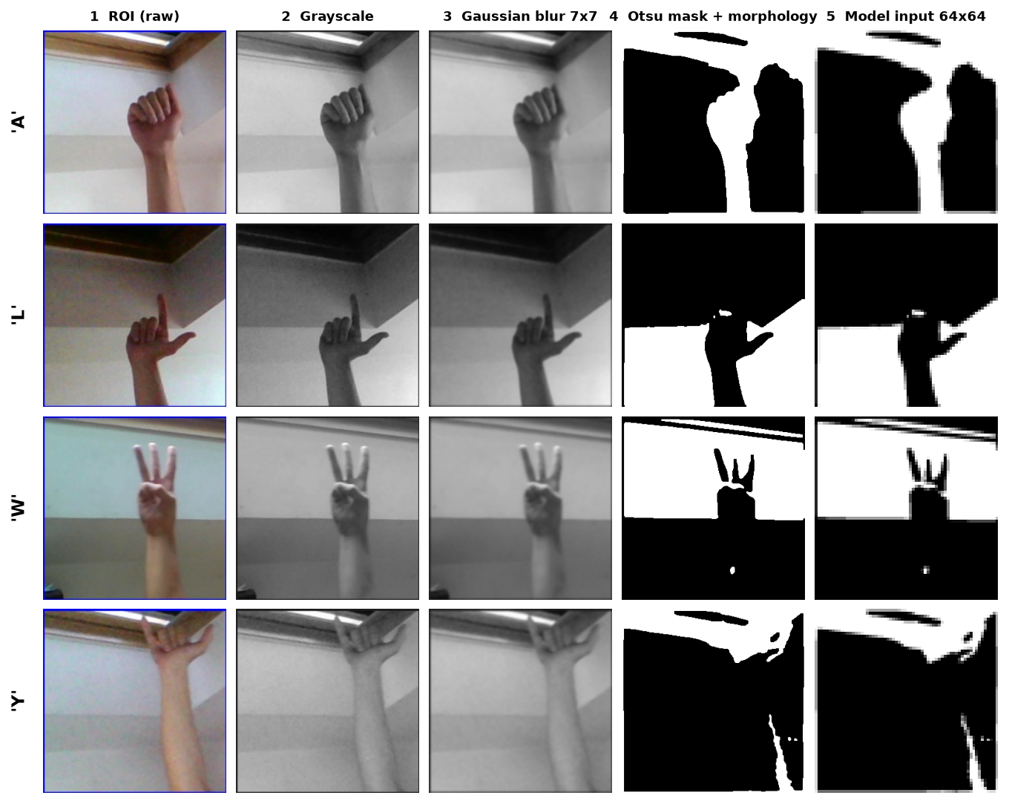
Figure 1: Preprocessing stages on real dataset images (limitation L3: background structure in the mask).
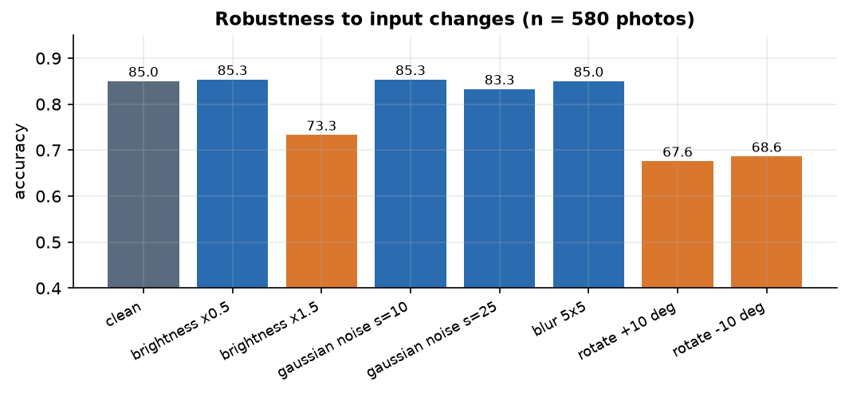
Figure 2: Accuracy under brightness, noise, blur and rotation changes (limitation L4).

4. WHAT WAS NOT MEASURED
Honesty about gaps matters more than a longer list of numbers. The following were not measured, and nothing in these documents should be read as a claim about them:
• accuracy on signers who are not in the dataset, and on new backgrounds or lighting;
• accuracy of typed words (letter error rate of whole sentences) with real signers;
• behaviour on a physical webcam (only Chromium's fake camera, fed with real photographs, was used);
• the wall-clock time of the saved 30-epoch training run (a separate 2-epoch benchmark gave about 9.9 s per epoch);
• power use, memory use under load, and behaviour under many simultaneous users;
• alternative architectures, hyper-parameter settings, skin-colour segmentation or landmark input;
• usability, accessibility with assistive technologies, and acceptance by the deaf community.
The 87.24 % accuracy on other photos of the archive was measured, but it is optimistic for the reason given in Chapter 8 and is not used as the headline.

